DiamondMind 3D Printer
V1.0
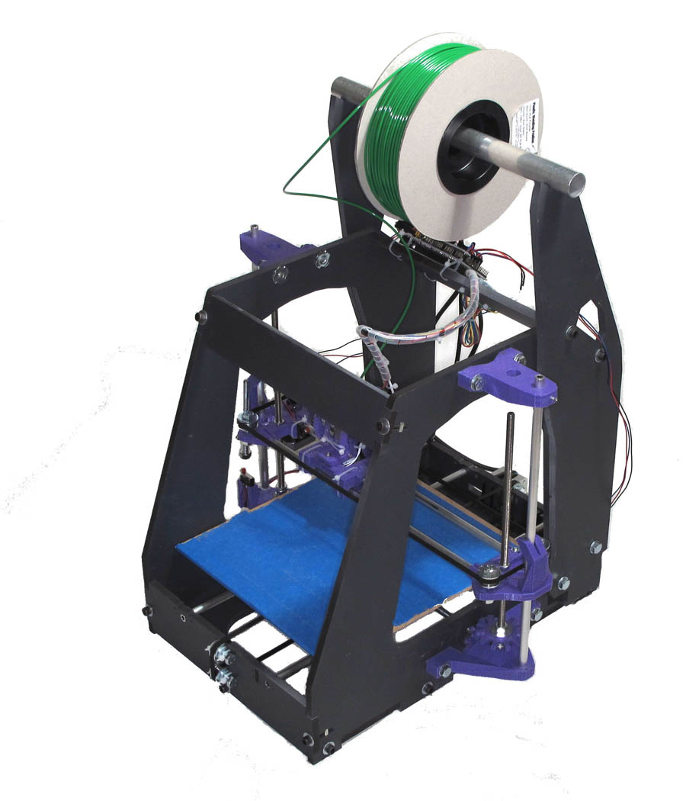

Documentation – Frame build

First steps

First, it is a good idea to unpack all the wooden parts and familiarise yourself with the pieces. You should have all of these:
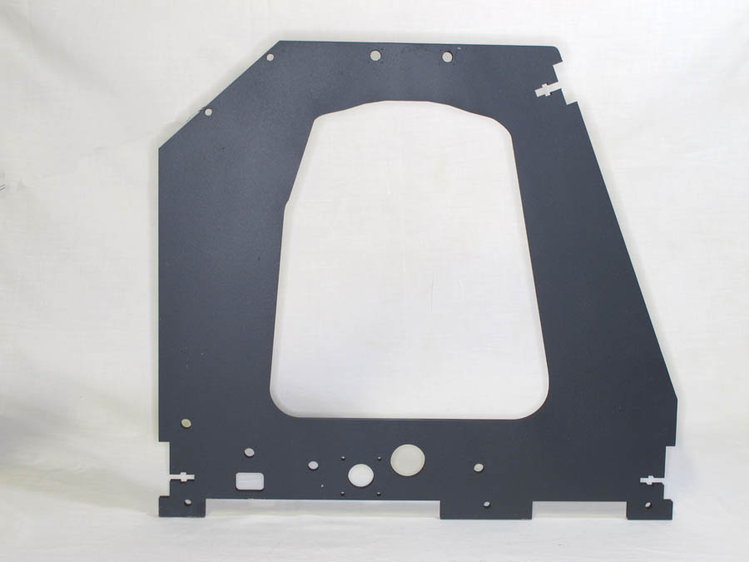Side Panel (x2)
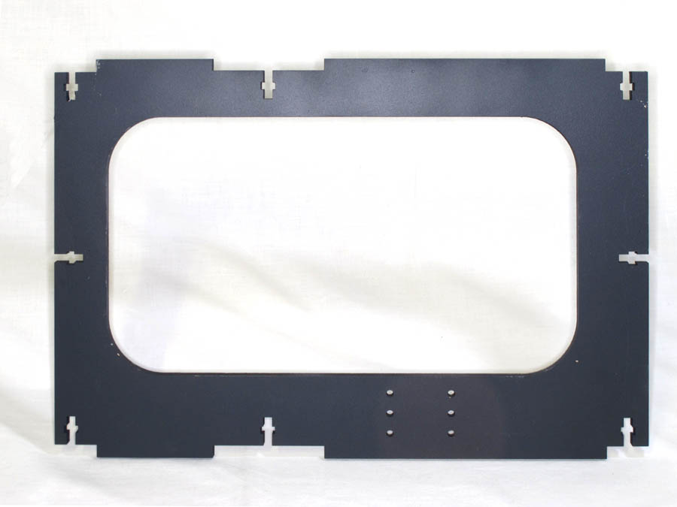Base (x1)
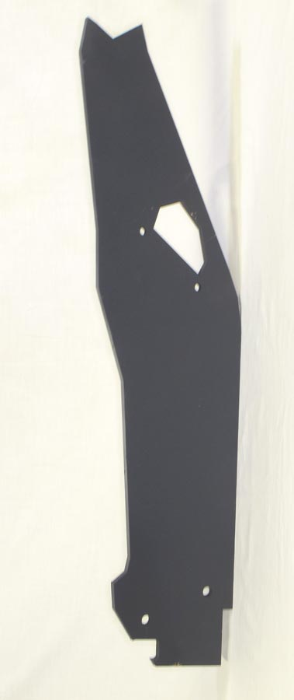Spool Holder (x2) aka "Devil's Ears"
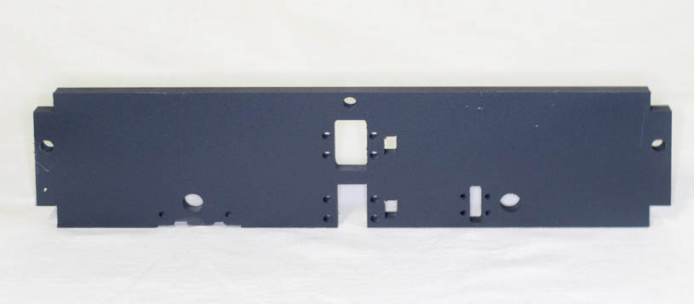Front Lower (x1)
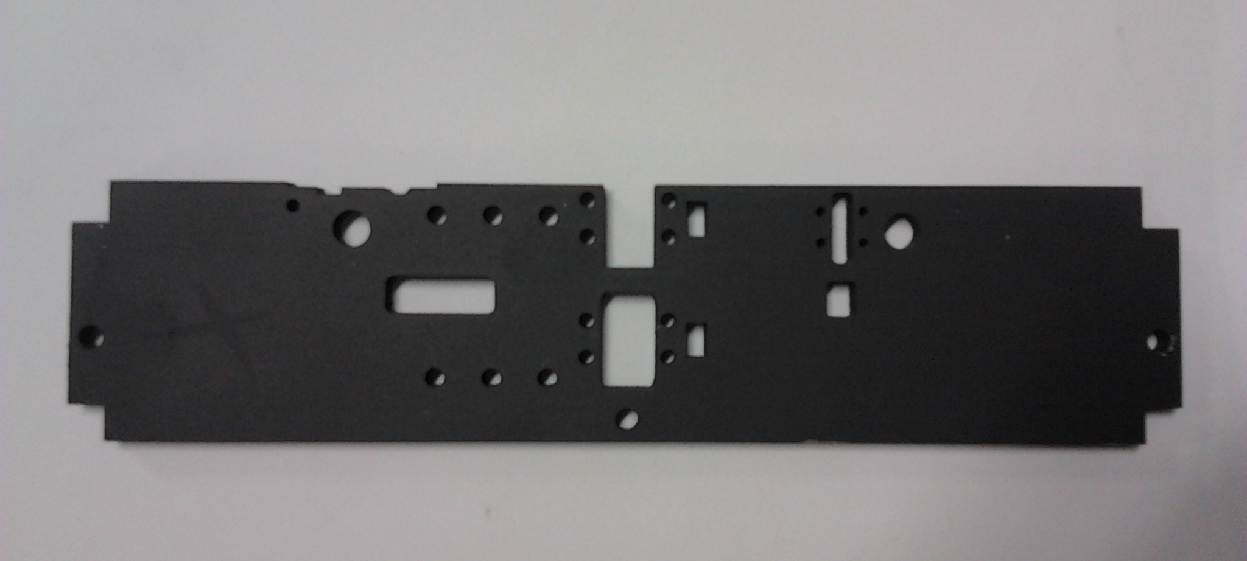Rear Lower (x1) – note 6 additional mounting holes & slot left of centre.

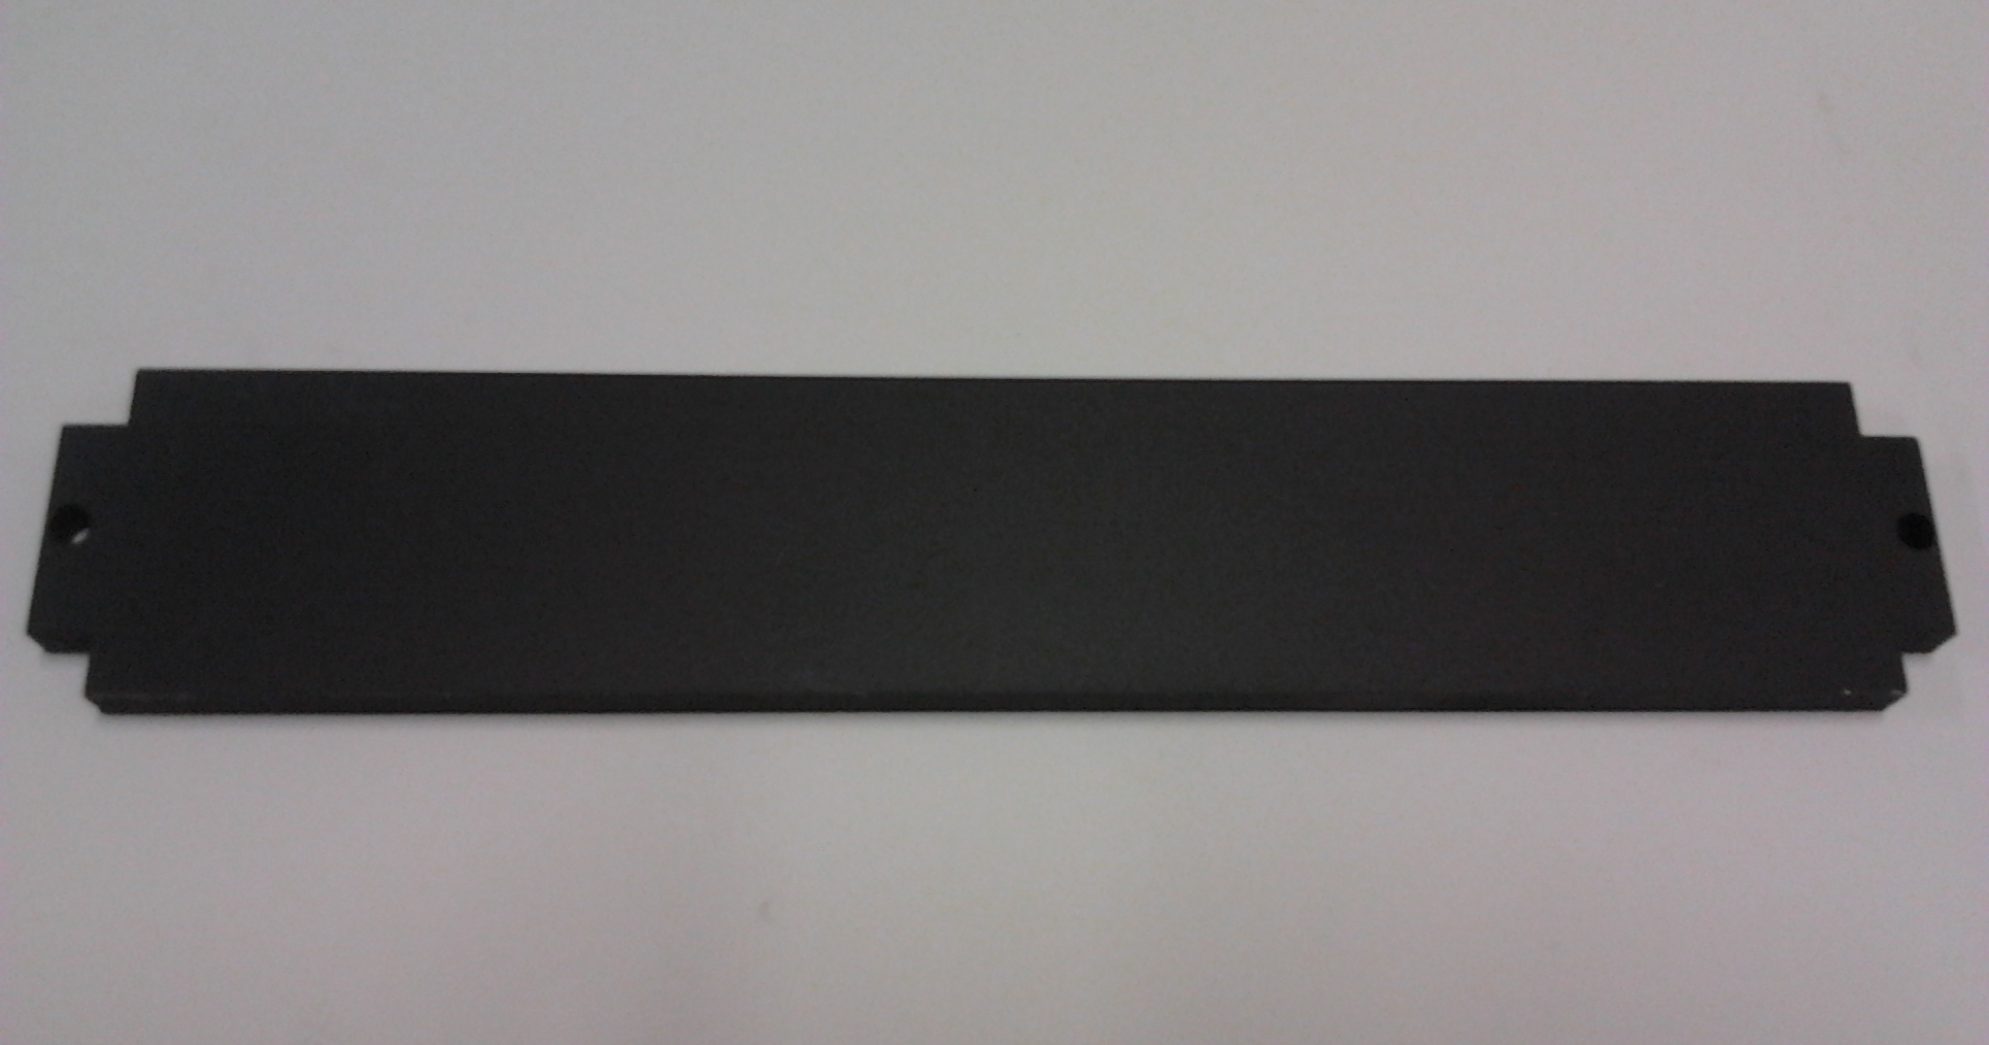Front Upper (x1)
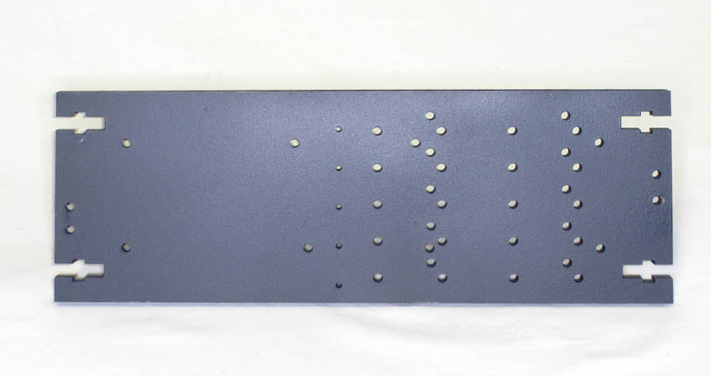Rear Upper (x1) aka "Cheese Board"

Next, check that you have the required tools to hand:
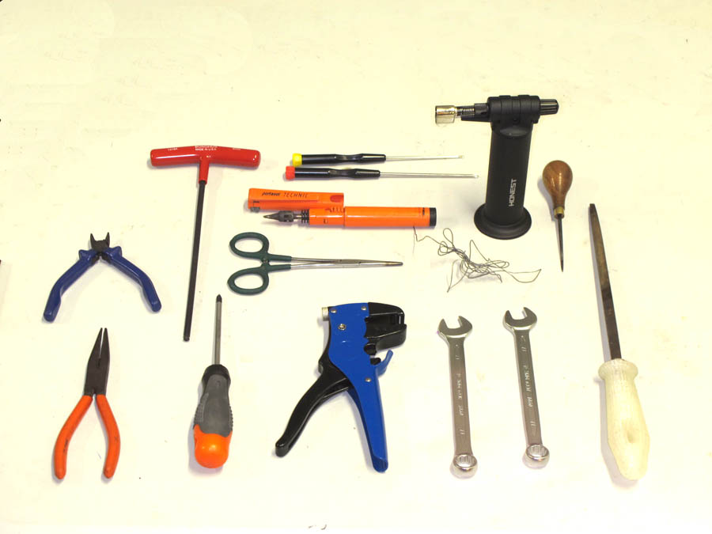
For those not familiar with the exact models above, the tools are (starting on the left):

- Side cutters (small wire cutters)
- Long-nosed pliers
- 5mm Allen key (Large T-shaped one shown here, traditional L-shaped one will suffice)
- Cross-head screwdriver with a 5mm shaft
- Long-shafted cross-head screwdriver with a 3mm shaft
- Small flat screwdriver (long shaft not necessary)
- Soldering iron (gas or electric) and electrical solder
- Forceps or sturdy tweezers
- Wire stripper of some kind
- Small blowtorch or blue-flame lighter
- At least one 13mm spanner. Pliers can be used as the second spanner if you must.
- A sharp spike with a 3mm tapering shaft (awl, knitting needle, old screwdriver etc.)
- A fine triangular file (or a flat file and a reamer)

Finally, select your favourite rubber or plastic mallet.

A block of wood as a buffer and some other sturdy clouting instrument can be used instead.
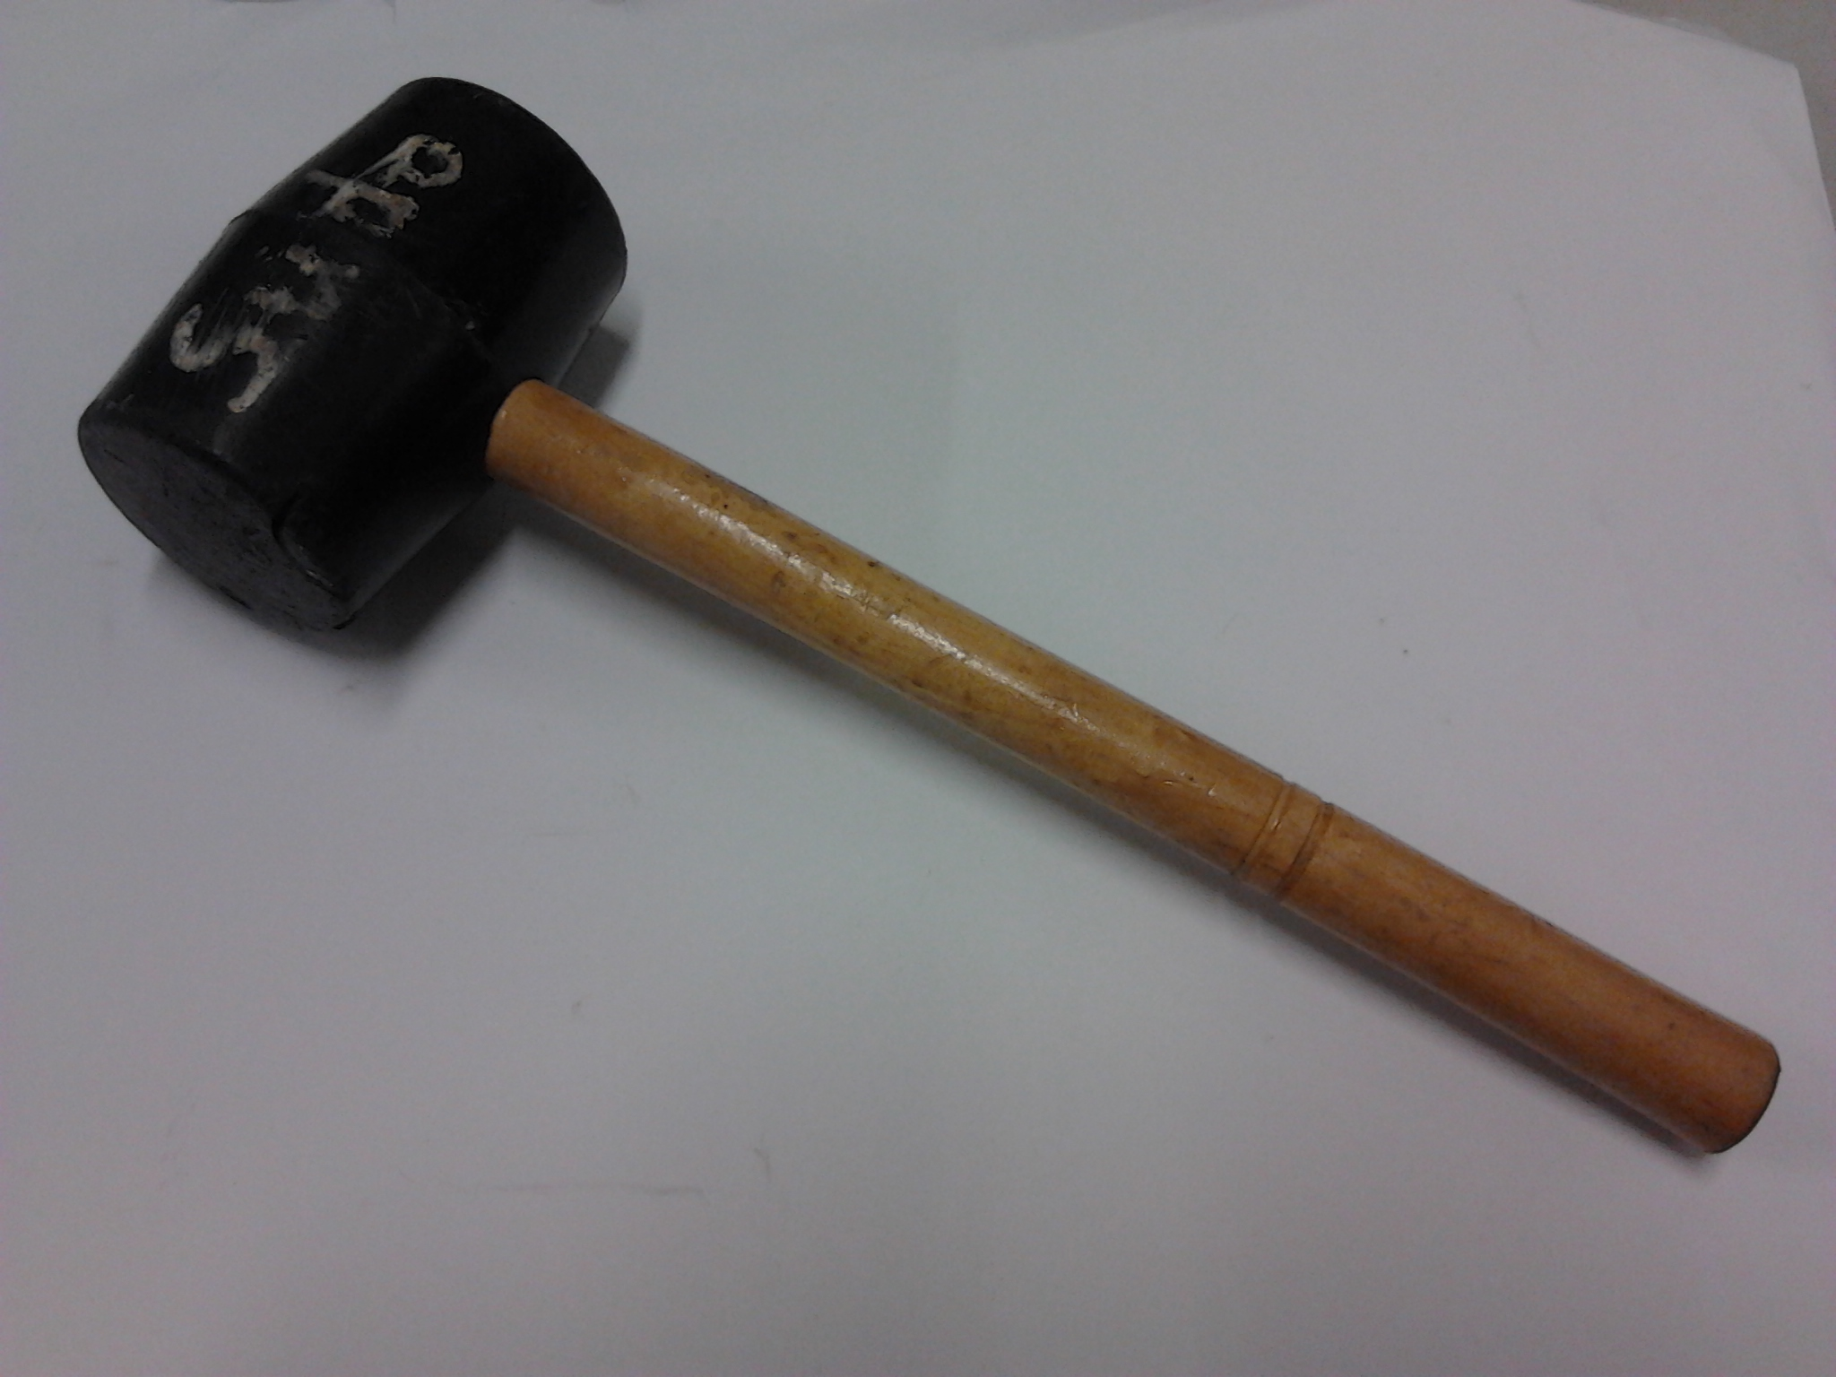

NOTE Attention to detail will be the key in building a well-operating printer. Make sure you use the correct screws, bolts, nuts, washers and so forth at the right places in the build. Some parts are quite similar, such as M8 standard nuts and M8 press nuts; M6 30mm cap screws and M6 40mm cap screws etc.

Frame build
This section covers the assembly of the laser-cut wooden parts to create the basic frame of the printer. Note that full rigidity will not be achieved until all the components of the frame are assembled, so care is needed not to bend it and snap bits off during construction.

Overview:
First, the M8 T nuts are set in place on the frame sides. Each side has 6 of the spiked nuts. Next the front and rear pieces are attached to the base. Third, the sides are attached to this. Finally the front upper and spool holder parts are attached.

The wooden parts tab into each other and are held secure with M6 square nuts fitted into slots in the wood.

Attaching the T nuts to the frame sides

The T nuts have 4 points that are pulled into the wooden frame so they are permanently located. Do this by using an M8 x 30mm bolt with a 24mm M8 washer and tightening with a spanner. The threaded shaft is meant to be larger than the hole which receives it.

The T nut points are positioned on the inside of the holes and there are tiny location holes in the wood for each of the points. Put the bolt with washer on the other side and tighten until the nut is pulled completely into the wood, then remove the bolt.

There are 6 T nuts per side.
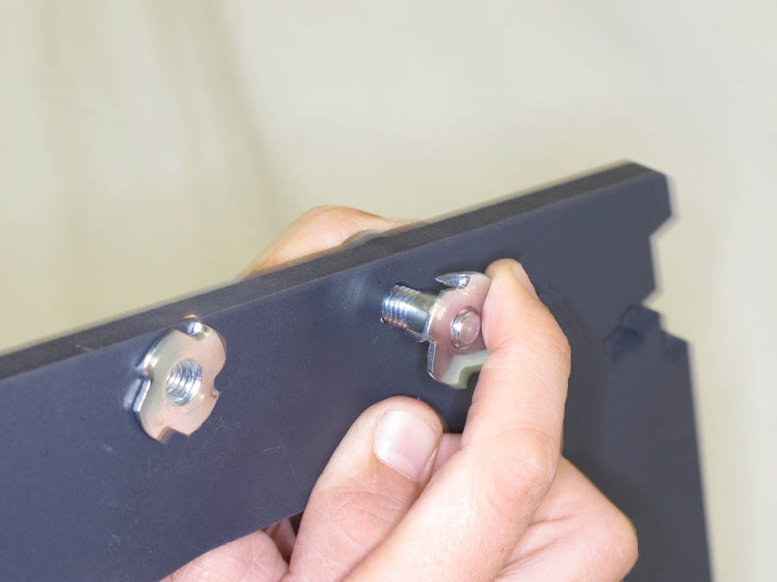M8 T nut - screw onto the bolt (washer on reverse)
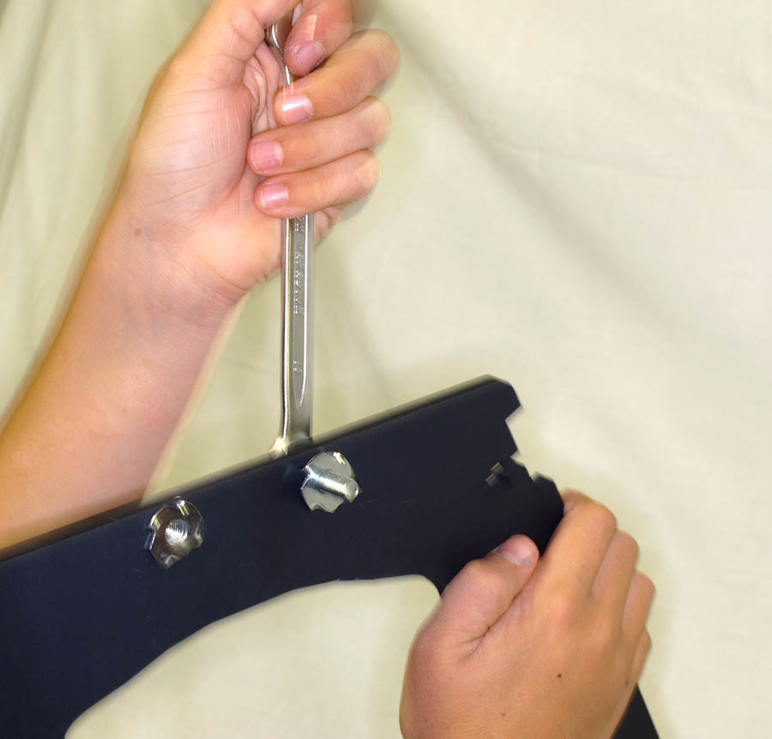Tighten M8 bolt with spanner
IMPORTANT – Make sure you put the nuts on facing sides of the side panels – double check this:
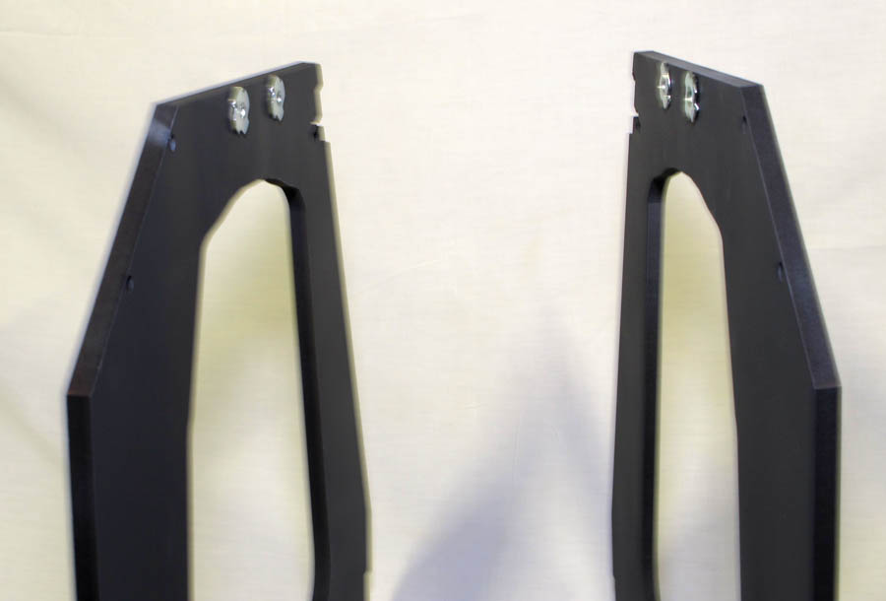Make sure the T nuts are on facing sides of side panels

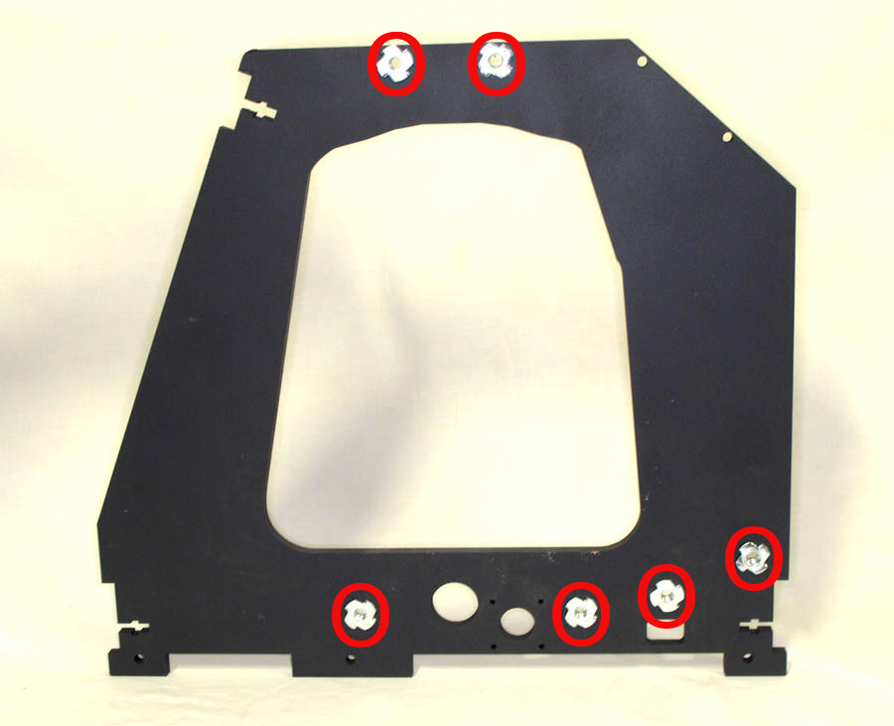T nut positions. Other side panel should be a mirror image.

Attaching the front and rear sides to the base (lower front / lower rear)
Take the base, rear and front lower, and two each of: M6 30mm cap screws, M6 washers and M6 square nuts.

The base board has a slot for an M6 square nut to fit in at each of the narrow ends.

Position the rear lower and base so the motor holes are at the back on the left (the Z motor is only there in the photos to show where the 6 mounting holes are):

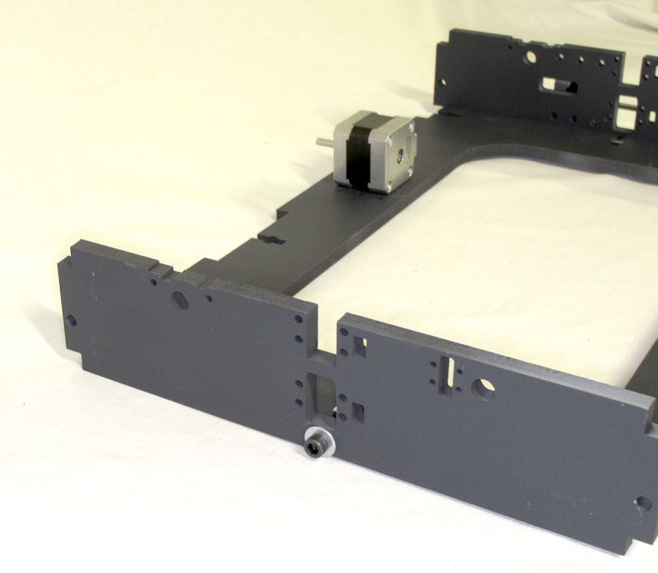Attach front/back to base - note screw in lower front panel
Slot the nut in the base and screw the M6 screw plus a washer through the hole in the front lower. One nut, washer and bolt hold each lower panel. Tighten screws with fingers. Repeat with rear lower panel ensuring motor mounting holes are on the left of the frame.
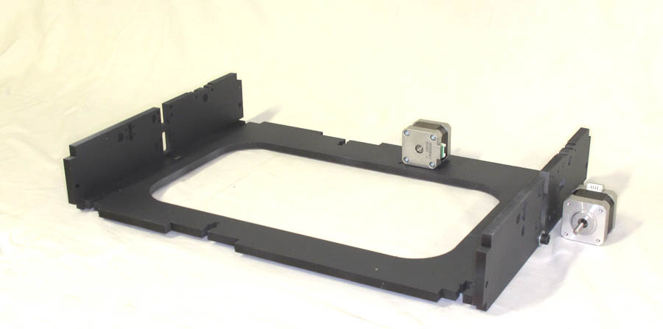Attach front/back to base - motors shown for positioning

Attaching the sides to the base and rear/front
Take the 2 side panels and 10 each of M6 30mm cap screws, M6 washers and M6 square nuts.

Position the side panels with the T nuts on the interior and the tabs on their lower edge engaged with the matching tabs on the base. It is easier to do them one at a time. Note that the base will be raised off the ground when correctly fitted.

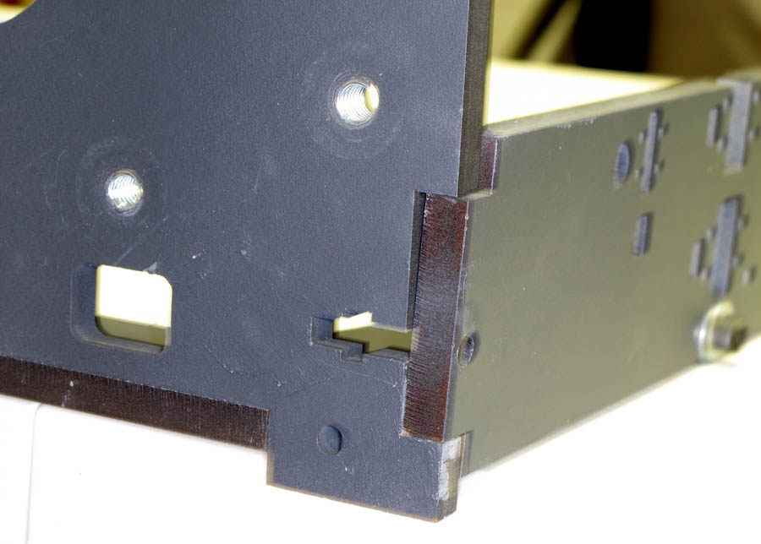Frame - attaching the sides. Front Lower slots into tab space on the sidepanel
Insert the M6 square nuts then fit the 30mm M6 cap screws with washers, finger tight. Then tighten all the M6 cap screws fitted so far with a 5mm Allen key until the panels pull in fully, then give ¼ turn more to seat the M6 square nut. DO NOT over-tighten to the point where the nut slots deform.
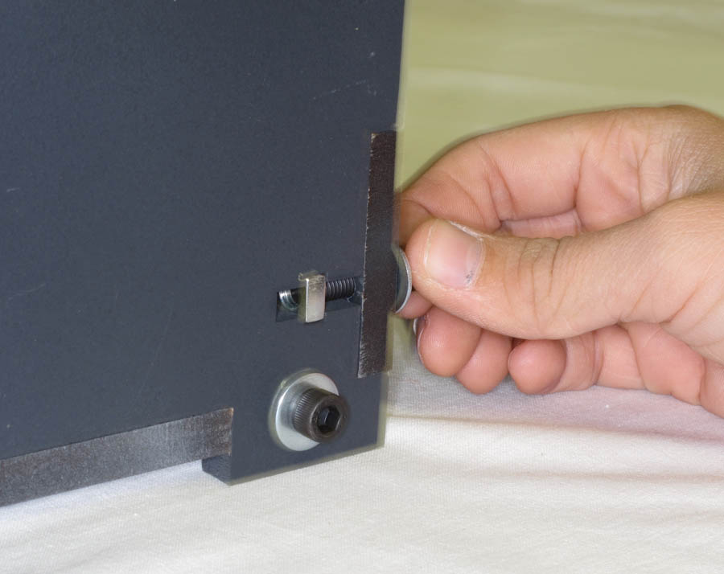Frame - attaching sides. Note the square nut located in slot

Attaching the front upper
Take the front upper part and 2 each of M6 30mm cap screws, M6 washers and M6 square nuts. Locate front upper into recesses at the top front of the frame. Put M6 square nuts in slots and secure as before with M6 30mm cap screws through the two holes in the front upper. Fully tighten.

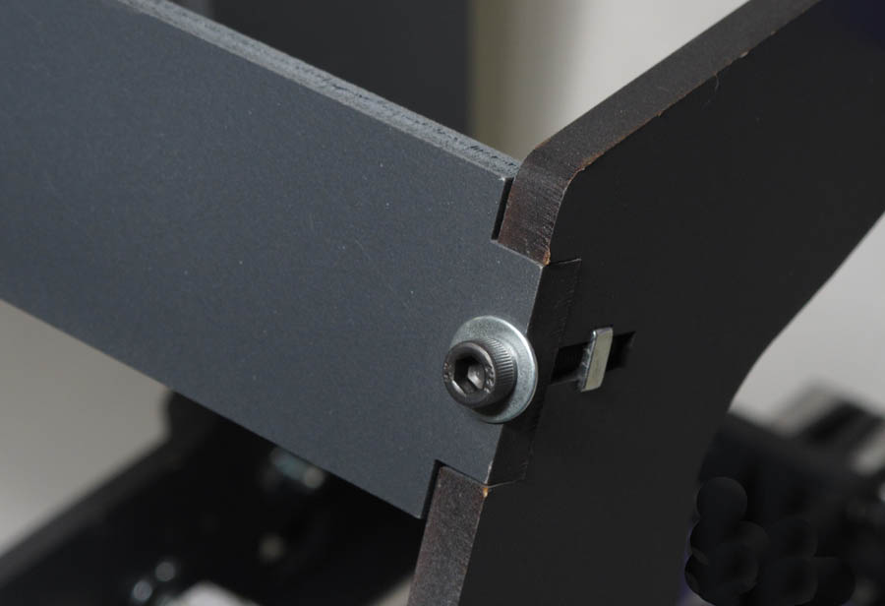

Attaching the rear upper & spool holders

This is done in two stages, first attaching the “Devil's Ears” to the body of the frame, then securing the “Cheese Board” through them.
Take the two spool holder panels and 4 each of M8 x 30mm screws, M8 x 16mm washers

Attach the spool holder panels to the frame through the two 8mm holes in their lower ends. Secure each panel with 2 M8 30mm bolts with washers, screwed into the T nuts at the rear of the frame finger tight only at this stage.

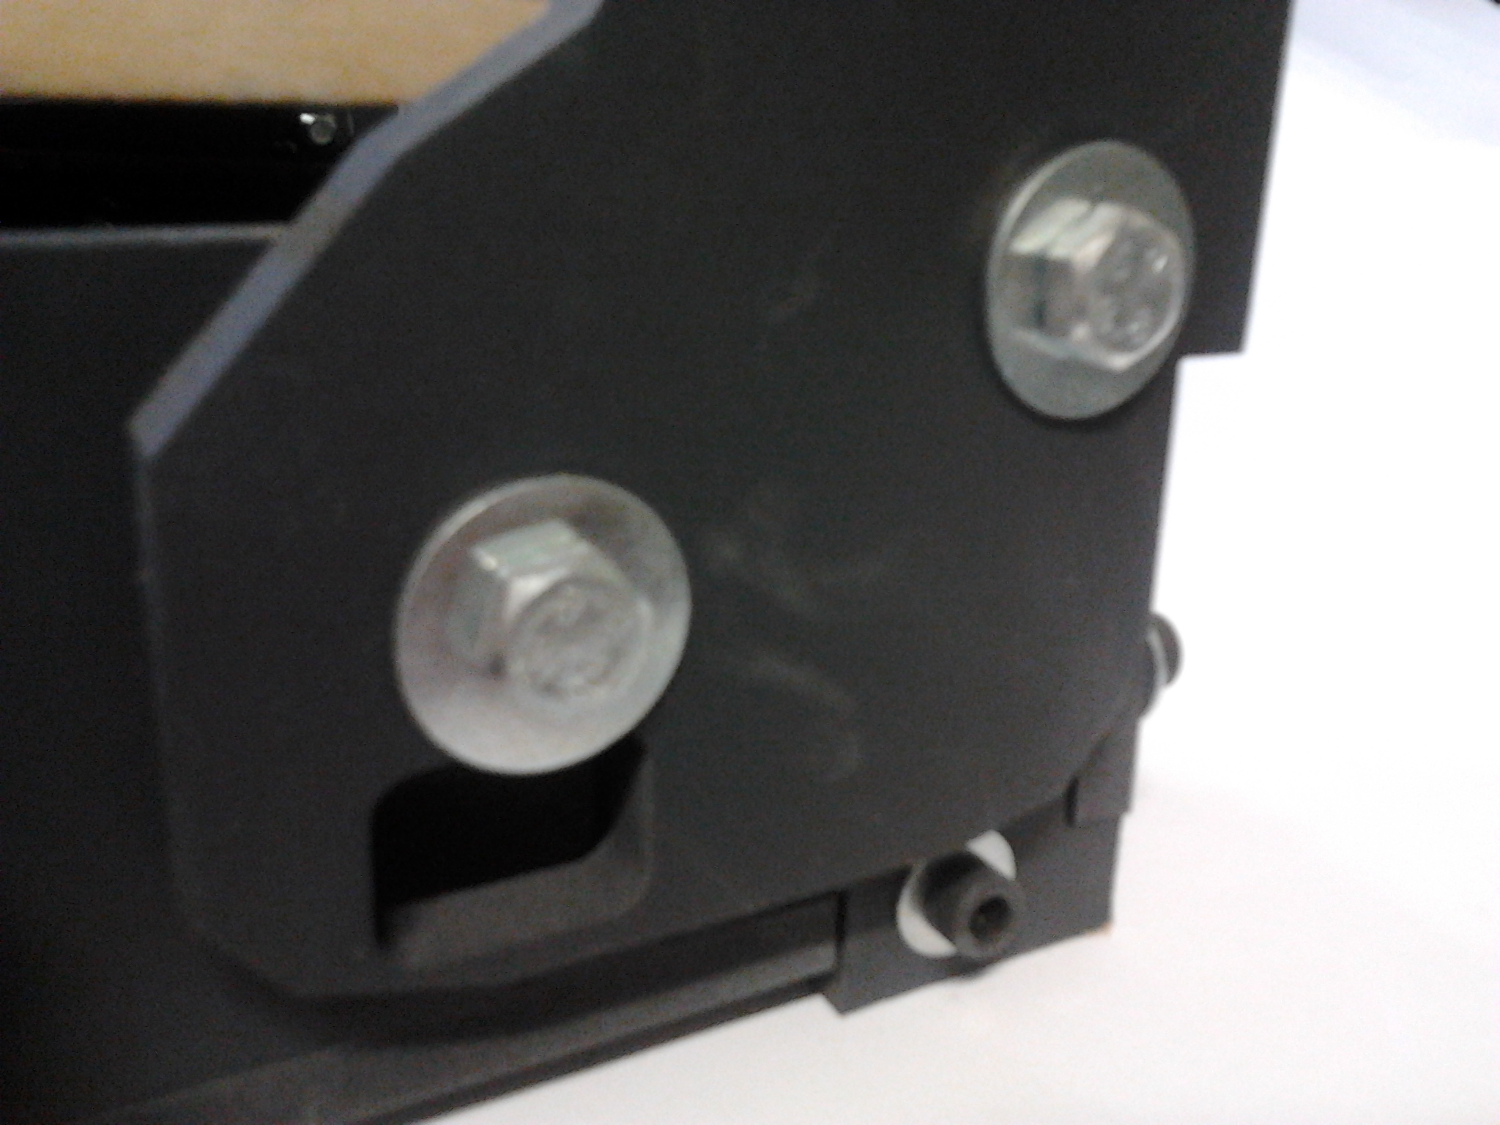
Take the rear upper part and 4 each of M6 40mm cap screws, M6 washers and M6 square nuts. Locate rear upper recesses so that they are adjacent to the 6mm holes at the top rear of the frame. These holes should line up with matching 6mm holes in the spool holders. The multipl;e hosles in the “Cheese Board” area should be on the left side of the frame. Put M6 square nuts in the rear upper slots and secure as before with M6 40mm cap screws and washers. Fully tighten, then tighten the 4 M8 bolts at the lower ends of the spool holders.
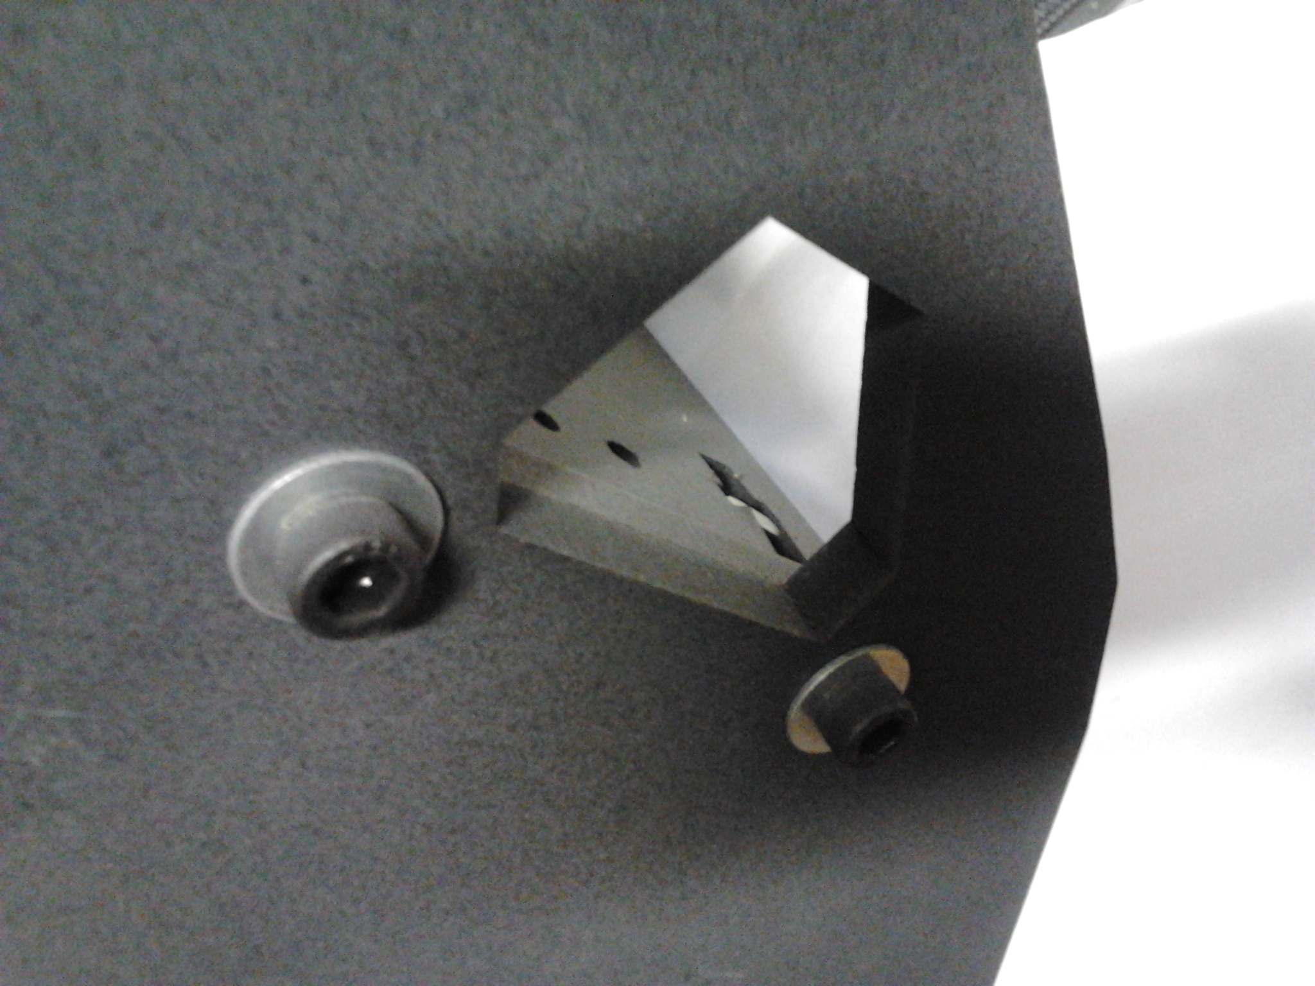
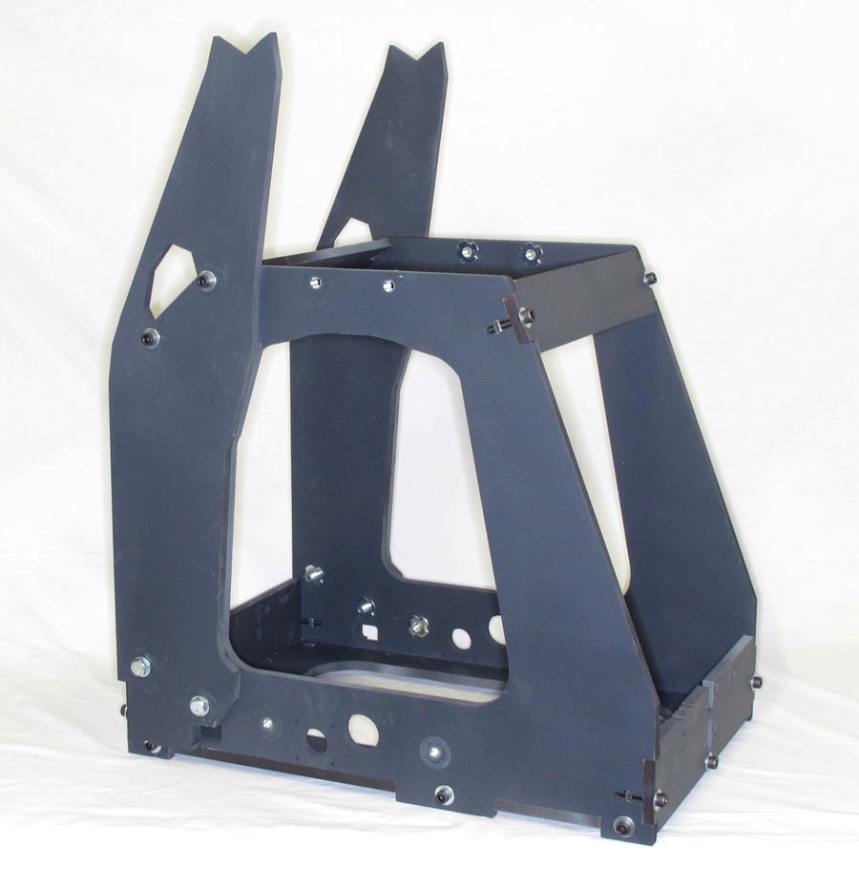
The frame is now complete! It should look much like this one:

